# Introduction

* https://www.golangprograms.com/remove-duplicate-values-from-slice.html
* https://www.youtube.com/watch?v=YS4e4q9oBaU
* 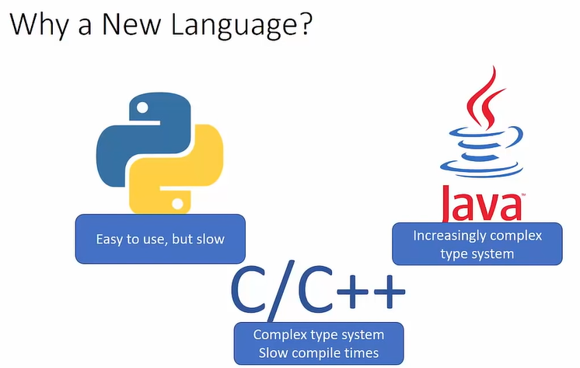
* 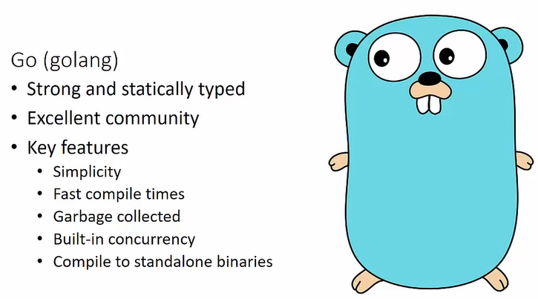
* 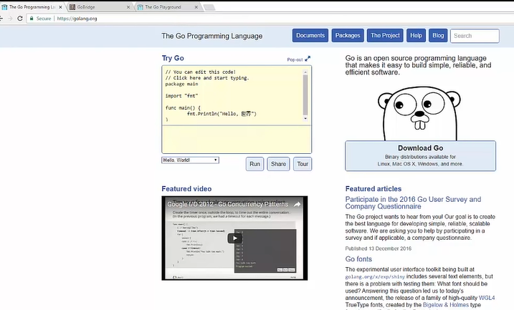
* 
* 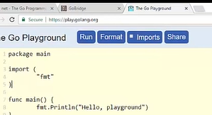
* Fmt help format string

# Setting Up a Development Environment

* Golang.org/dl/
* 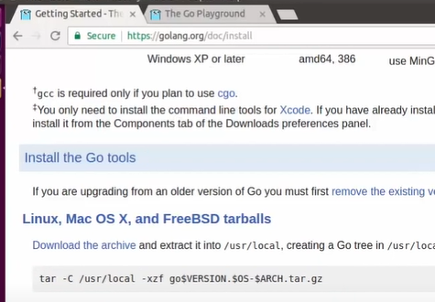
* 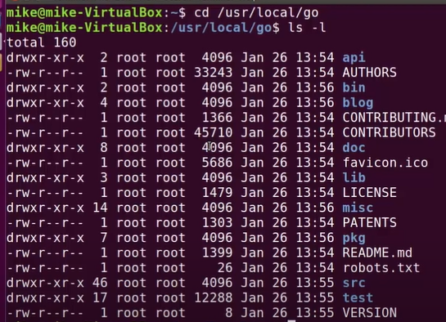
* 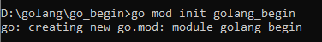
* Go mod init golang_being
* Go build
*  install
* F5 for run

# Variables

* 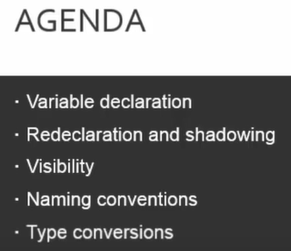

<https://play.golang.org/>

* 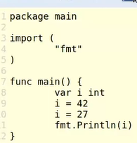 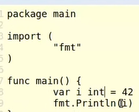 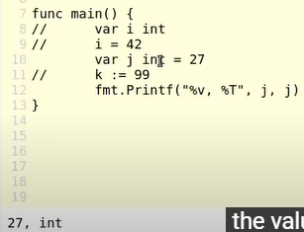
* 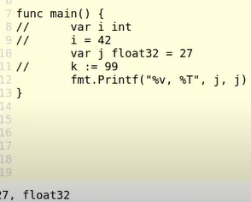 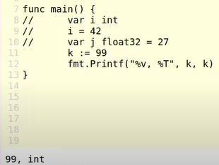
* 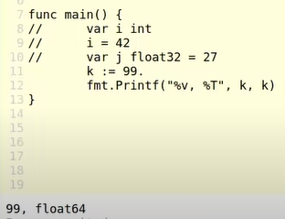 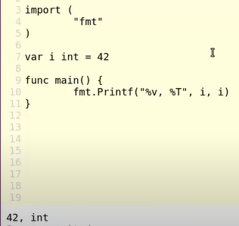 :=
* 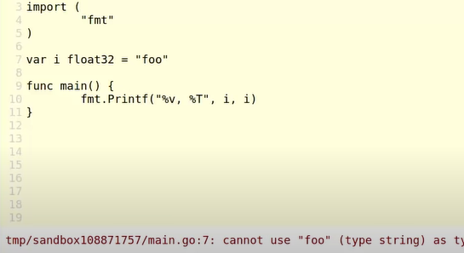
* 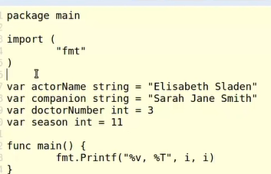
* 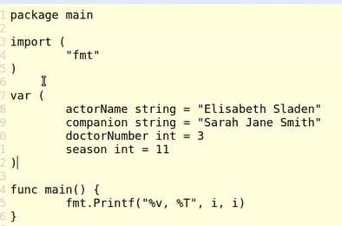
* Declare multiple variable, var
* Clear name variable
* 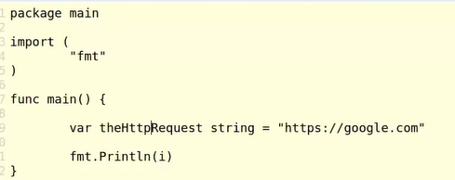
* Copy variable shadow , conver type you want
* 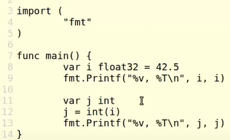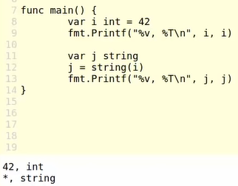
* Int to string
* 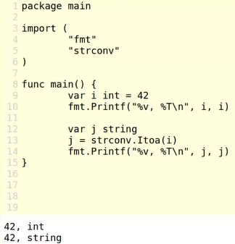
* 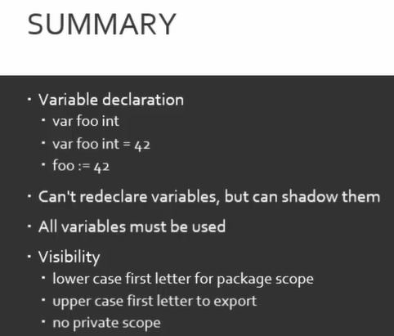 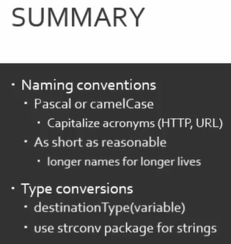

# Primitives

* 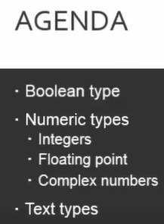 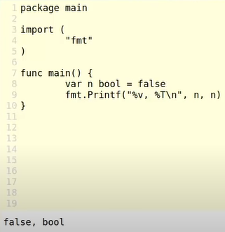
* 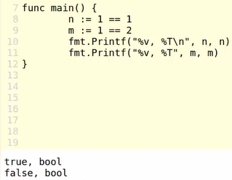 default bool type is false
* Int8, int16,…
* 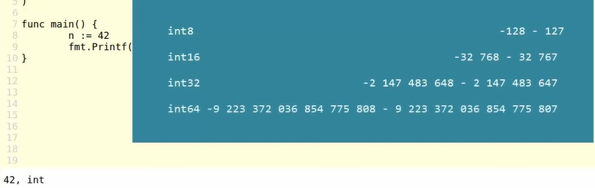
* Uint16
* 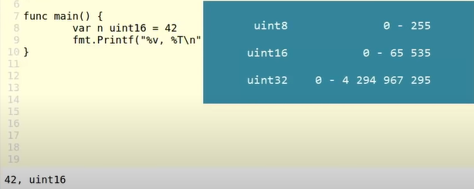
* 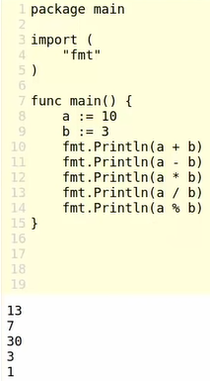 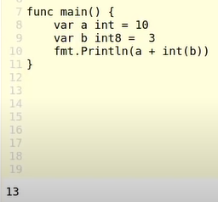
* +-*/%, & | ^ &^
* 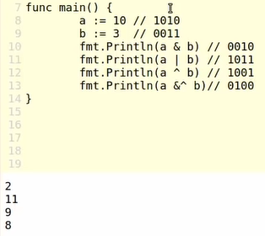 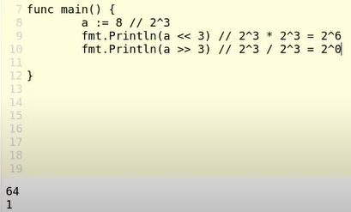<< >>
* 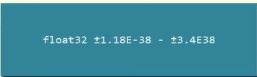float 32
* 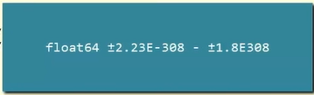
* 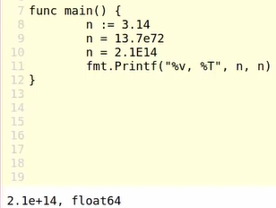
* 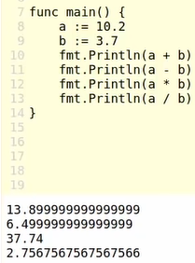 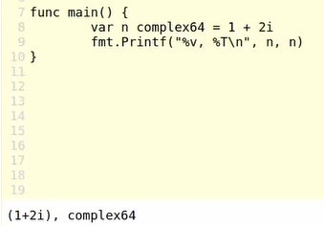
* 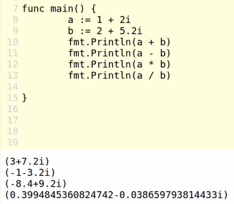 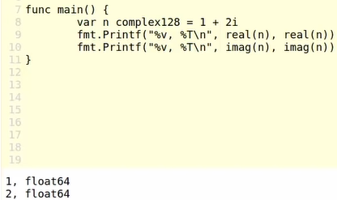
* 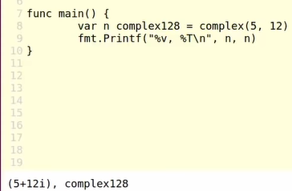
* String s[2]
* 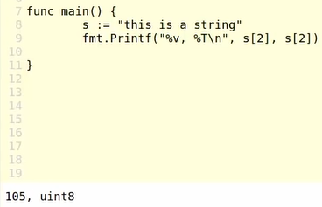 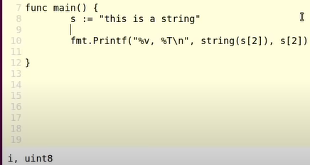
* Add string,
* 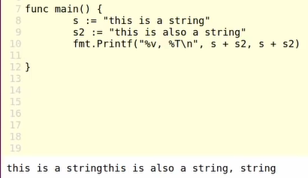
* 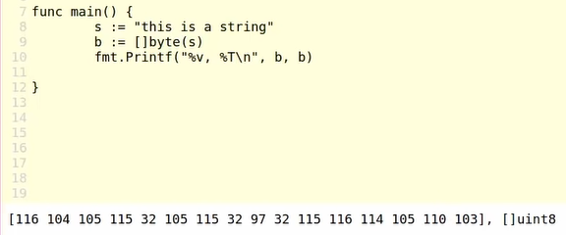
* Rune
* 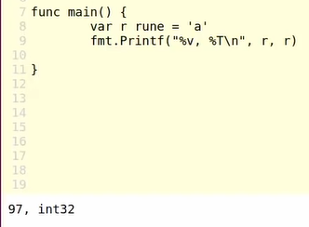 zero values is false
* 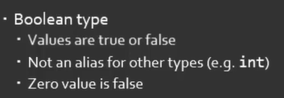
* 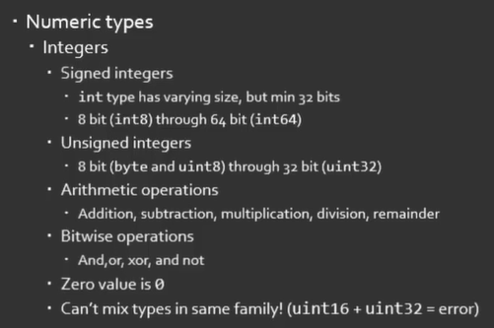
* 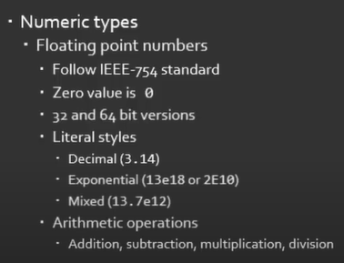
* 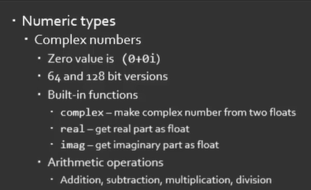
* Text types
* 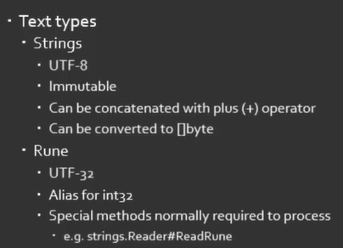

# Constants

* 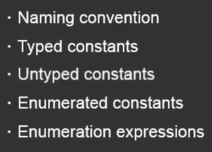
* 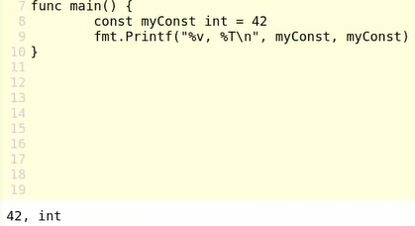 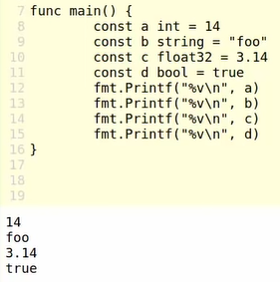
* 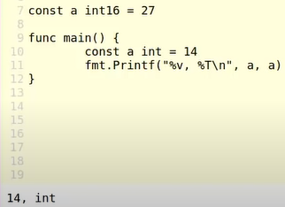 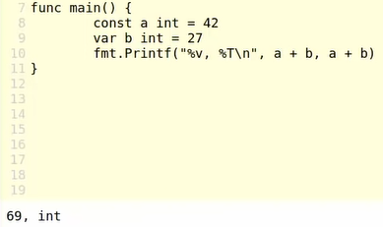
* 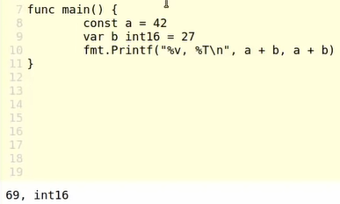 const with undefine type
* Multiple constant
* 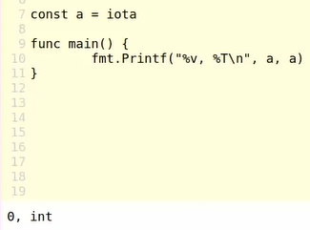 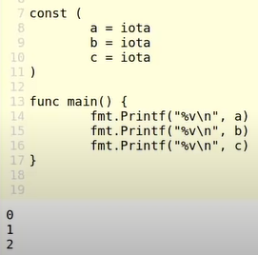
* 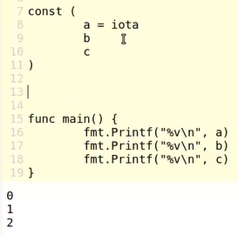 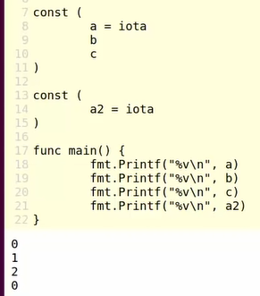iota
* 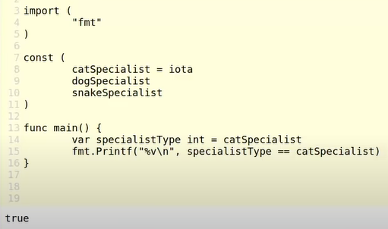
* 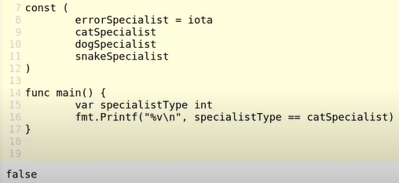
* 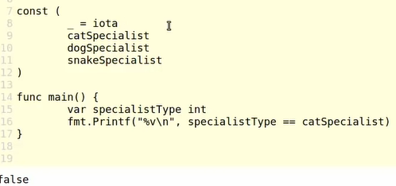
* 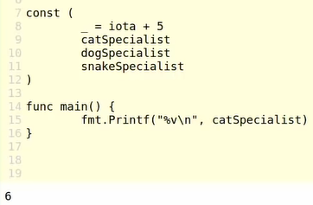
* 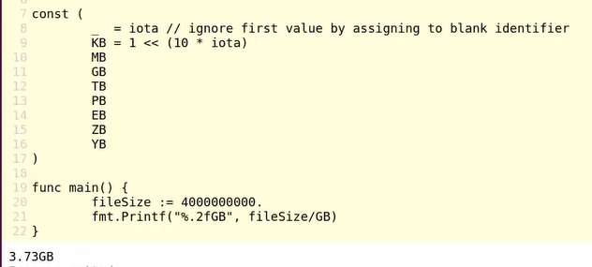
* 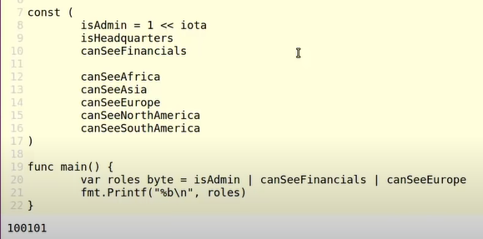
* 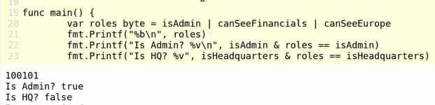
* 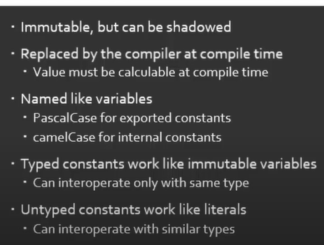
* 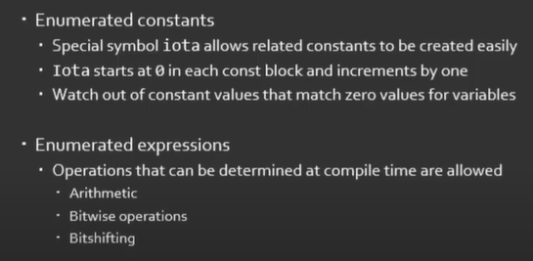

# Arrays and Slices

* 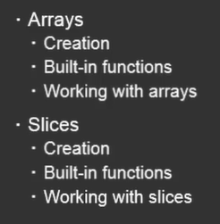
* 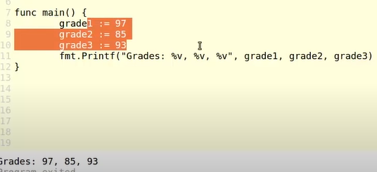
* 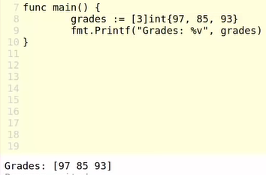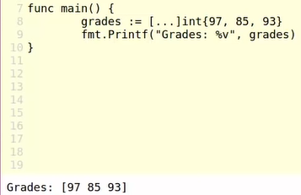
* 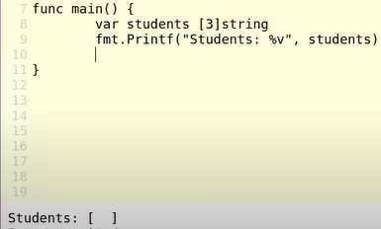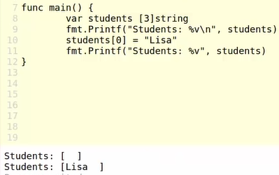
* 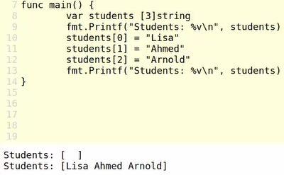
* 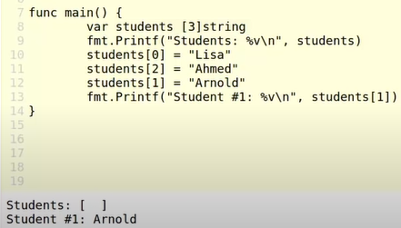
* 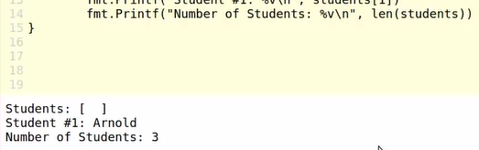
* Length of array
* 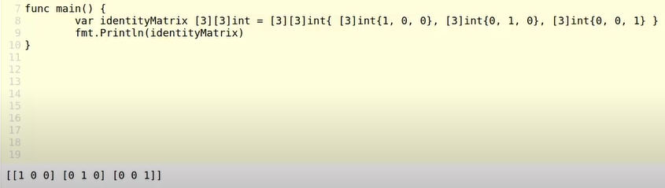
* 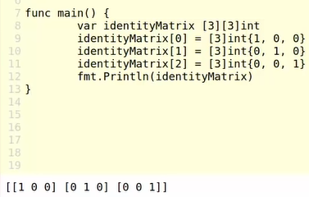
* Shadow array, change value on index in array
* 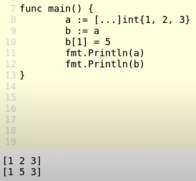 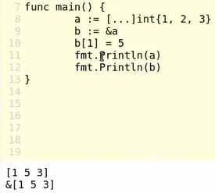
* 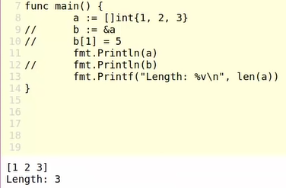 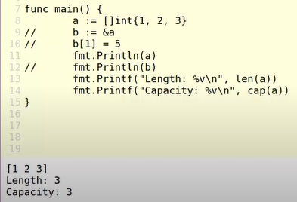
* Capacity: sức chứa
* 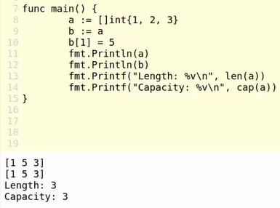
* 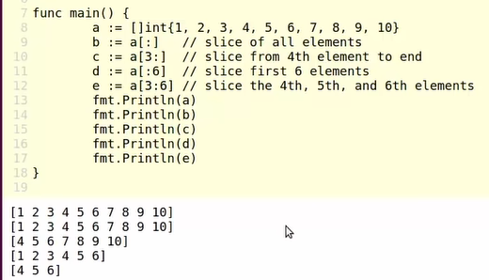
* 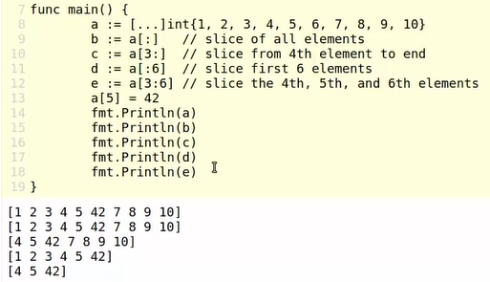
* 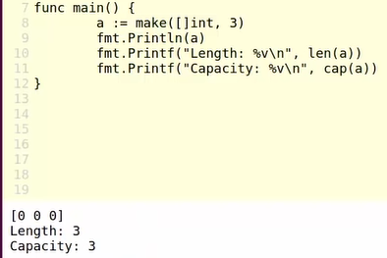make in array
* 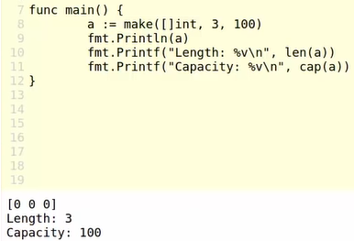 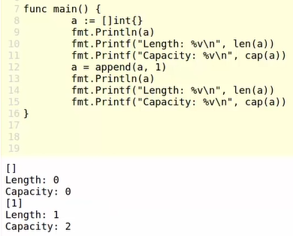
* Append
* Same way
* 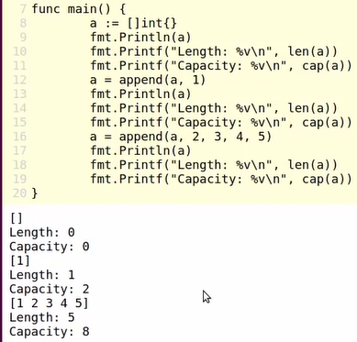 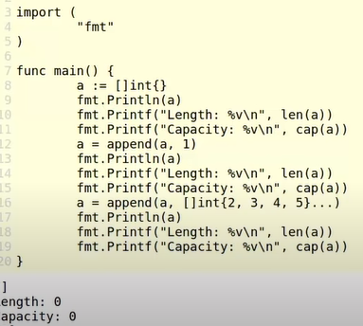
* 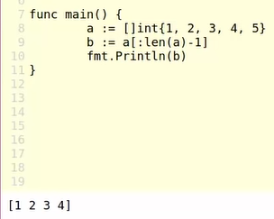len || append
* 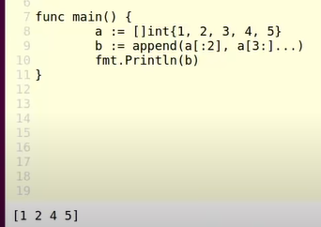 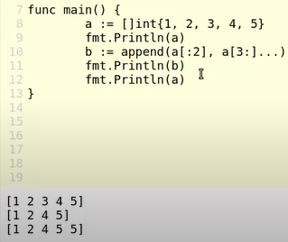
* Three way for declare array
* 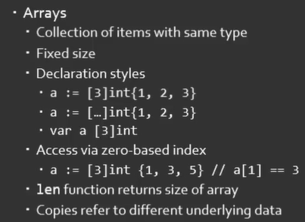
* 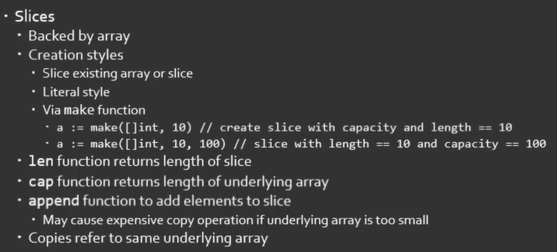

# Maps and structs:

* 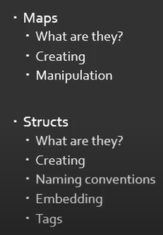
* 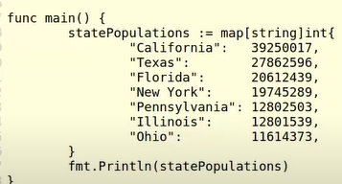
* 
* 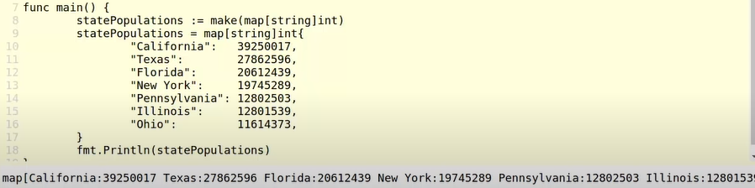
* 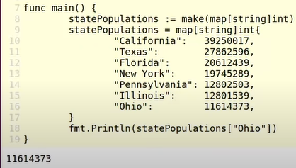
* Add element:
* 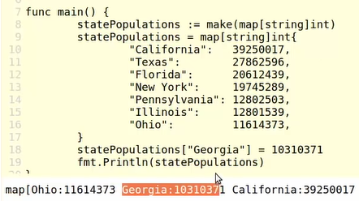
* Remove element
* 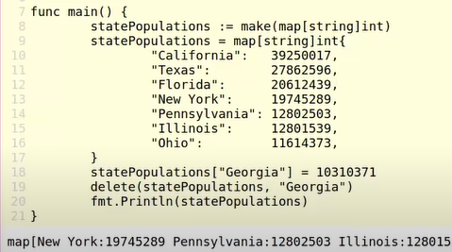
* 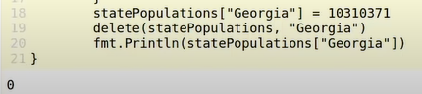
* 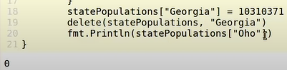
* 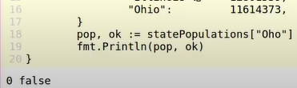
* 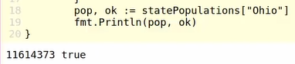
* 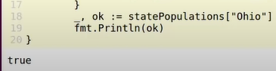
* 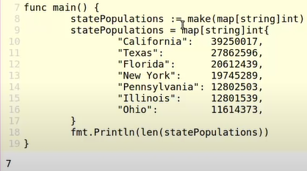 len map
* struct
* 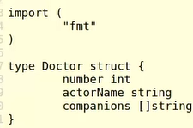 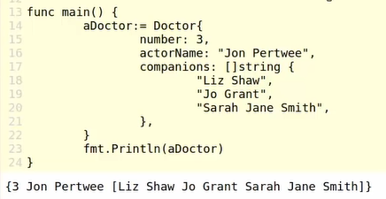
* 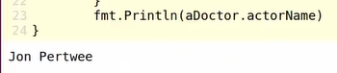 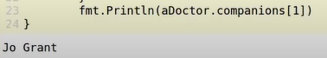
* 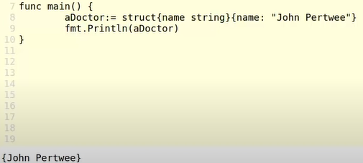
* 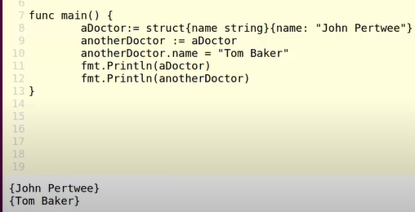
* 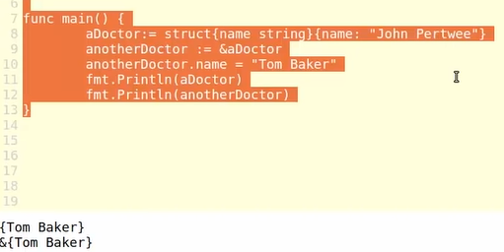&
* 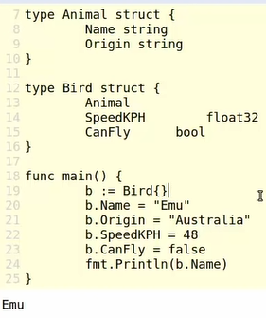 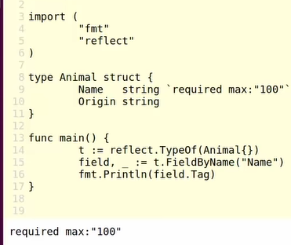
* Condition in struct
* 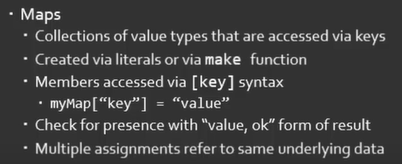
* 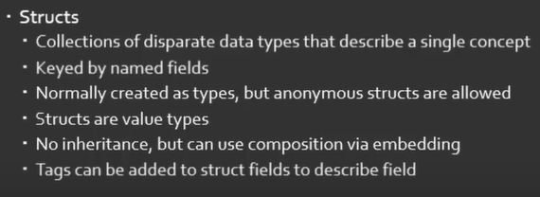

# If and Switch statements

* 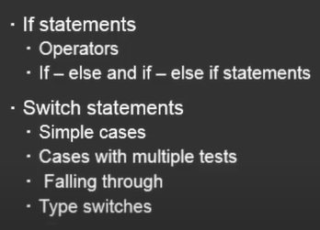
* 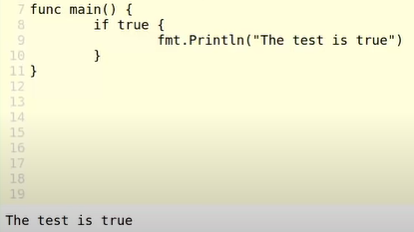
* If don’t have {} will errors
* Fist statement is initializer.
* 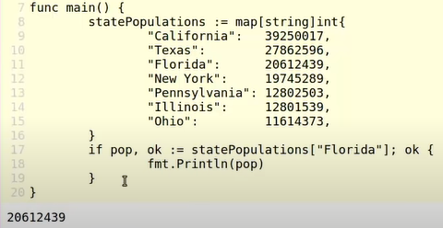
* 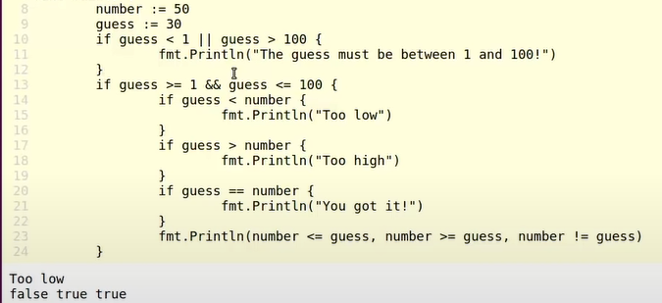
* == > >= <= ||, && , !
* 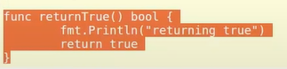
* Else if
* 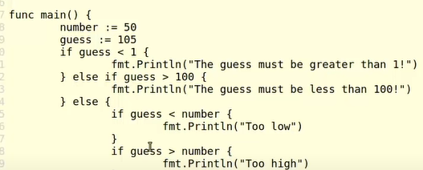
* 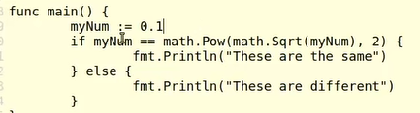
* 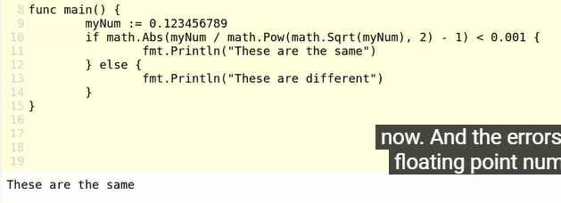
* 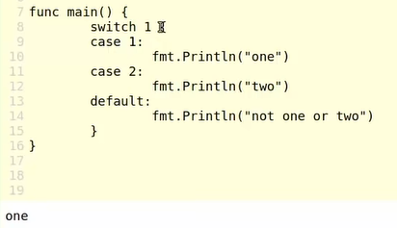 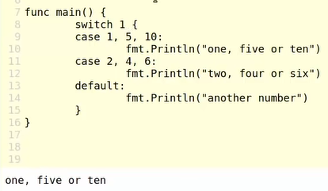
* 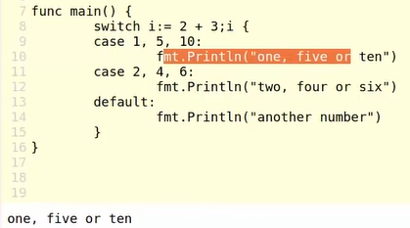 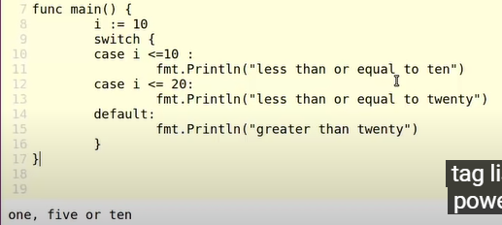
* 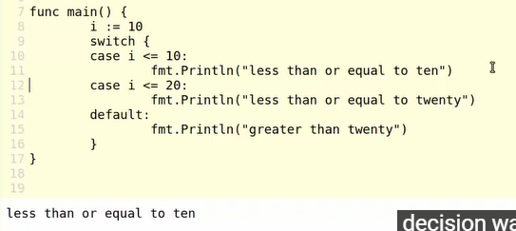
* Switch
* 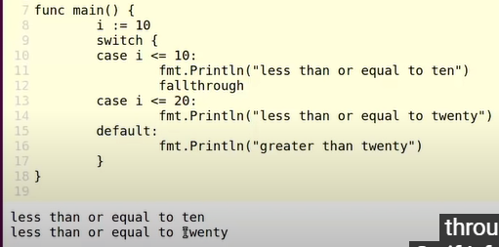
* Type of variable
* 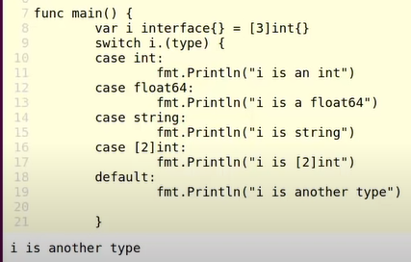
* 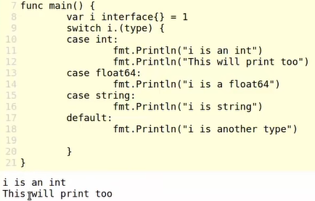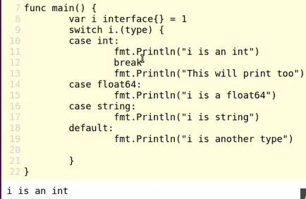
* 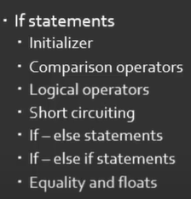 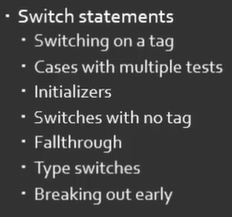

# Looping:

* 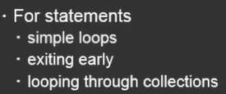
* 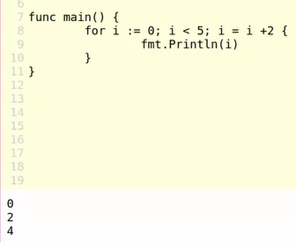 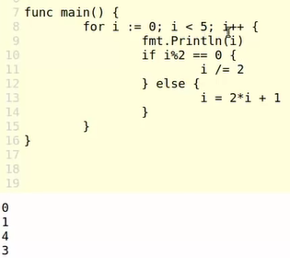
* don’t have ++ , --
* 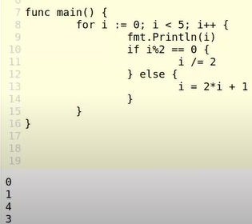 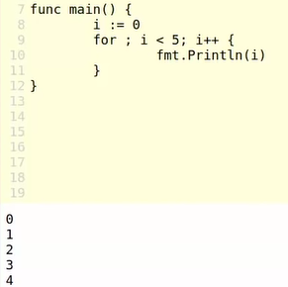
* 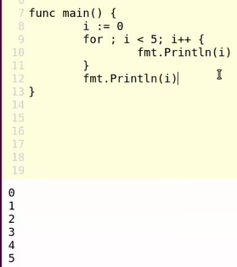 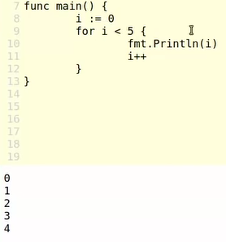 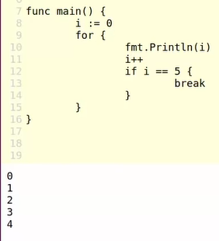
* Break and continue in for
* 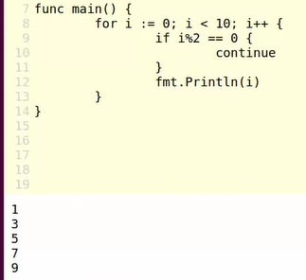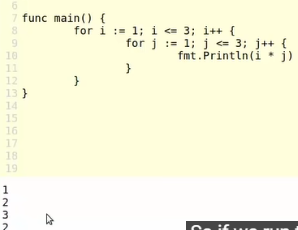
* 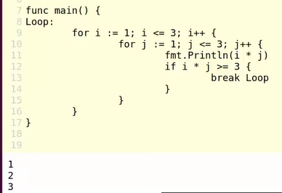break: the loop that is going to break out of is the closest loop that it can find.
* Loop through array with range
* 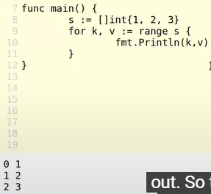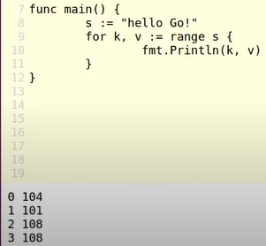
* 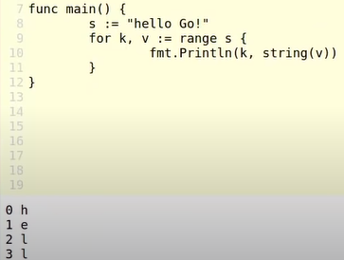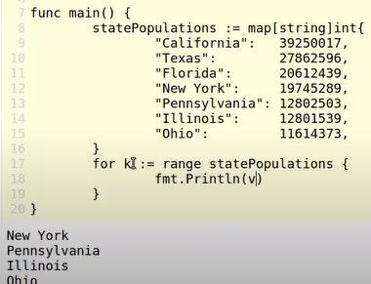
* So how to print value, not key
* 
* 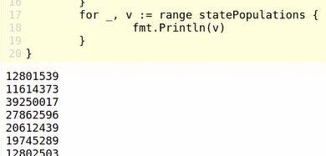
* 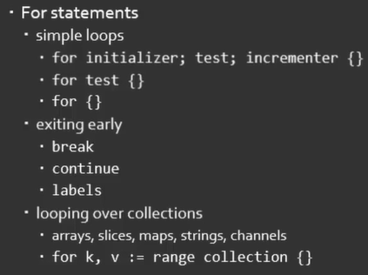

# Defer, Panic, and Recover

* 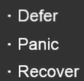
* http, get
* 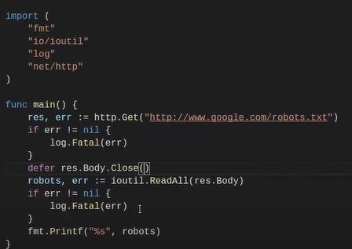
* 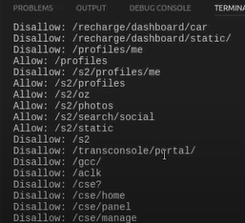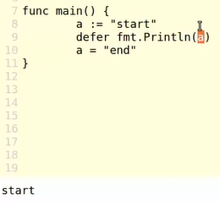
* When main function run 1 time, defer will run next
* http
* 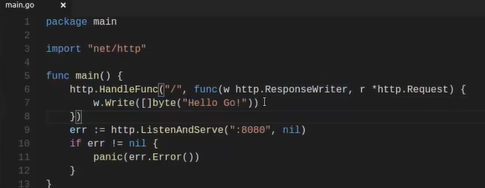
* 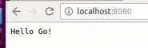
* 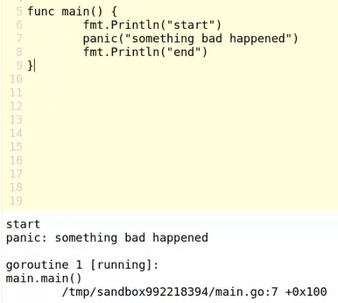

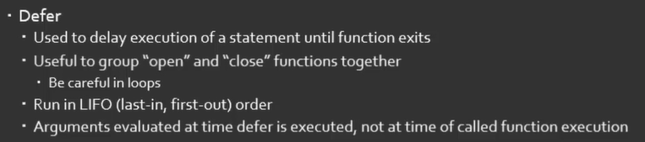

* 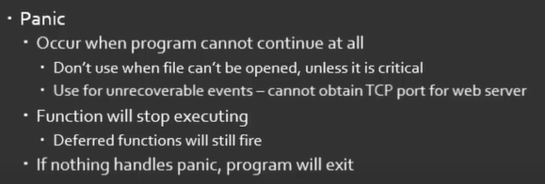

# Pointers:

* 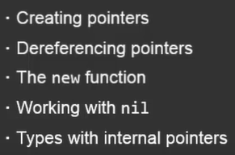
* 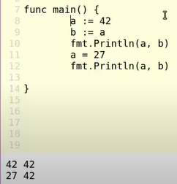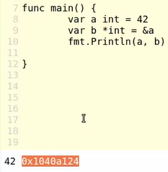
* B it isn’t holding the value 42, it’s holding the memory location that’s holding this data.
* 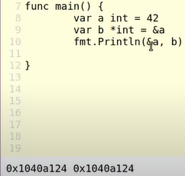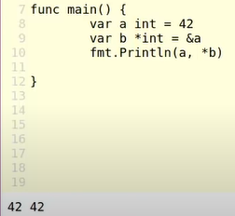
* 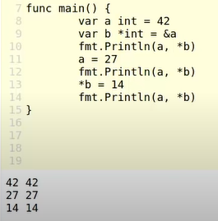it’s in fact the same data.
* 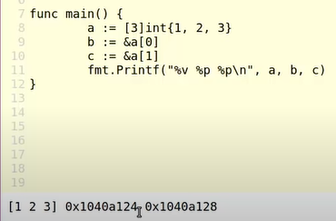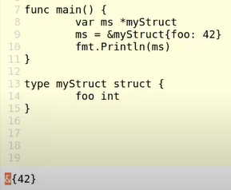
* A pointer to a my struct and then use the address of operator in this object initializer,
* 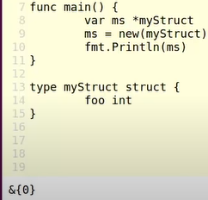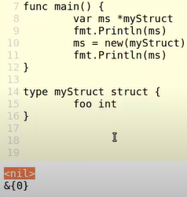
* 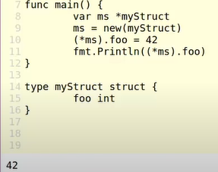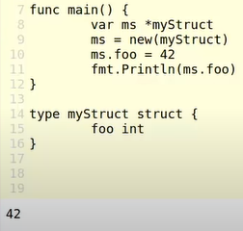
* B not change because b is a copy of the array that we stored in a and so they update independently of each other.
* 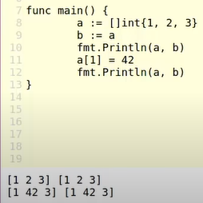 [] is the slice
* well, the slice is copied just like the array, but the effect of the copying is a little bit different. Because in the version with an array, the values of the array are actually considered intrinsic to the variable. So a is holding the values of the array, as well as the size of the array and that size is held that way we can do bounds checking
* However slize is actually a projection of an underlying array, and so the slice doesn’t contain the data itself, the slice contains a pointer to the first element that the slice is pointing to on the underlying array. So what that means is that when we work with slices, the internal representation of a slice actually has a pointer to an array. So while line nine is still copying the slice a into the slice B, part of the data that gets copied is a pointer, not the underlying data itself, when you’re sharing slices in your application, you’re actually always going to be pointing at that same underlying data.
* map
* 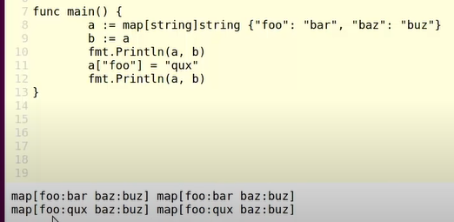
* When working with map and slices in a go application, you have to be very, very careful to keep in mind at all times who’s got access to that underlying data. Because passing slices and maps around in your application can get you into situations where data is changing in unexpected ways.
* When copy struct, it’s actually going to copy the entire structure unless you’re using pointers.
* 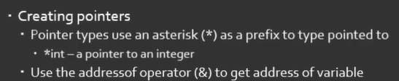
* 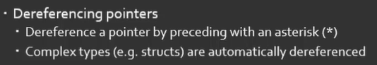
* 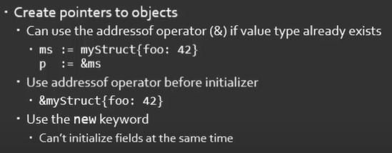
* 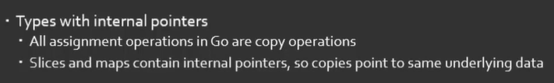

# Functions:

## Basic syntax

* 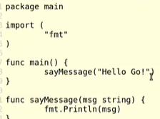 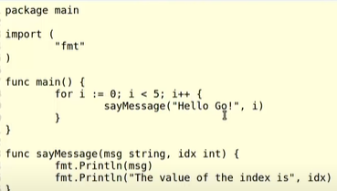

## Parameters

* 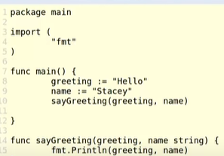
* 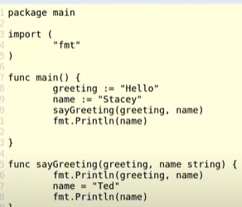 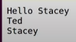
* Function with pointer
* 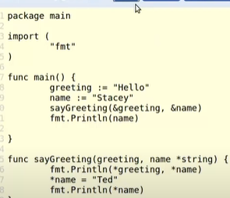 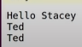
* … three dot
* 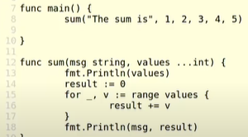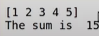

## Return values

* 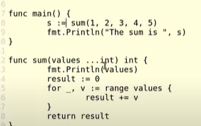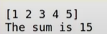
* 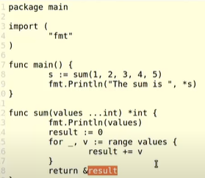 Pointer return
* 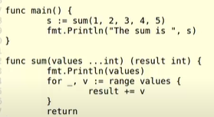name return value
* Return error in function
* 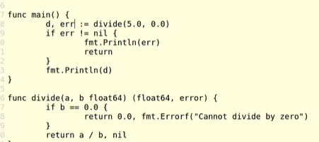

## Anonymous functions

* 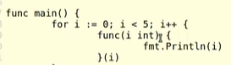 
* 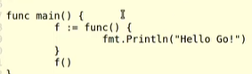 pass function to variable

## Functions as types

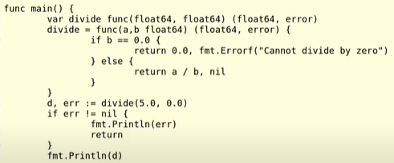

## Methods

* 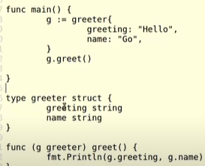
* I’ve got struct called greeter that greeter struct
* In my main functions, I’m declaring a greeter struct, and then I’m calling this function preceding it with the struct that I have here.
* So we call the method just like we were accessing a field, except we have the params here where we can pass some arguments in.
* When we declare that method, we’re actually going to get access to that type right here in this part. So what’s going to happen when we call the greet method is the greet method is going to get a copy of the greeter object. And that’s going to be give the name g in the context of this method.
* Now when we use this syntax right here, notice that we’re specifying greeter as a value type, we don’t have a pointer here. So this is what’s called a value receiver. The received object In this greet method is the value greeter. So what that means is just like any order time that we’re working with values, we are getting a copy of the struct, we’re not actually going to get the struct itself. So if I change the value of the name field here, and then print out in main field out, then it’s no big surprise that even though I assigned an empty string to name in greet function, the Name field here, up here in the main function, it didn’t have any effect. Because down here in this method, we’re operating on a copy of the greeter object.
* If pointer
* 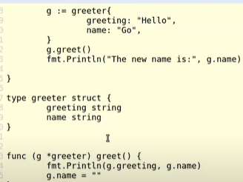 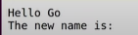

## Summary

* 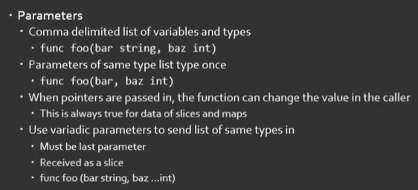
* 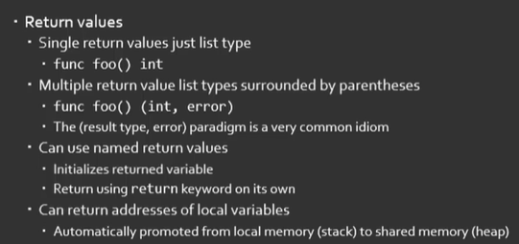
* 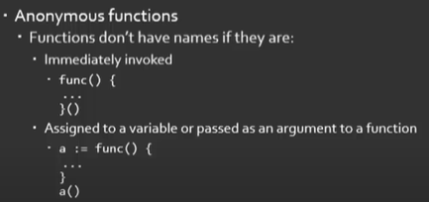
* 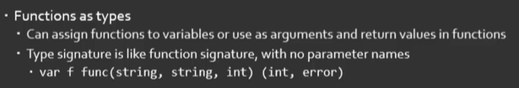
* 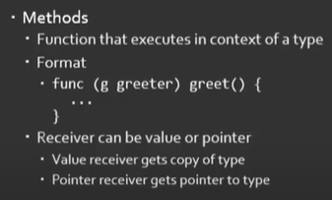

# Interface

## Basic

* 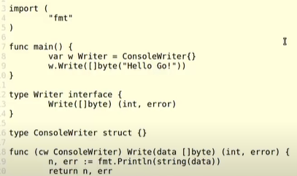
* Inrefaces don’t describe data, interfaces describe behaviors.
* consoleWriter will be a struct, we don’t actually explicity implement interface, we’re going to implicitly implement the interface.
* The w variable here is holding a writer, which is something that implements the writer interface. I don’t actually know the concrete type, though. SO when I call the write method down here on line nine, I know how to call that because that’s defined by the interface. But I don’t actually know in my main function, what’s being written to , that’s the responsibility of the actual implementation. SO I could replace this with a TCP writer, I could replace it with a file writer, I could replace it with any other kind of writer. And so I get what’s called a polymorphic behavior.
* Why nine doesn’t care what it’s writing to, I specify that behavior before that. But then anything that’s going to use this w object just knows that it can write to it. And so it can take advantage of that behavior.

## Composing interfaces

* 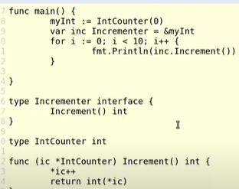 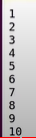

## Type conversion

## Implementing with values vs .pointer

* 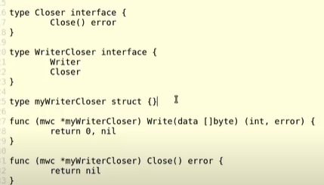
* 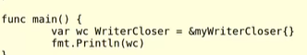

## Best practices

* 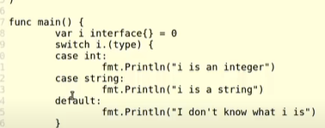 is a intteger
* 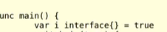 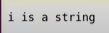
* 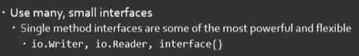
* 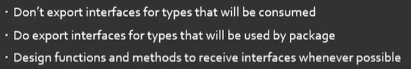

## Summary:

* 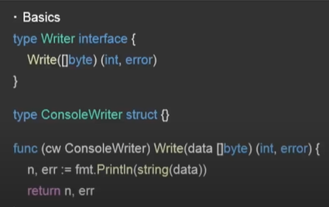
* 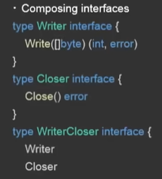
* 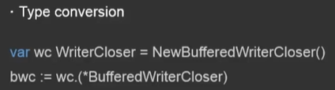
* 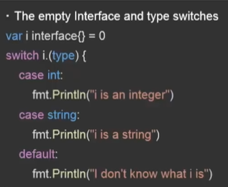
* 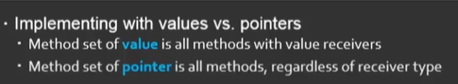
* 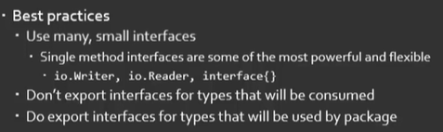

# Groutines

## Creatin goroutines

* 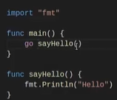 all we have to do is in front of the function invocation, jus type the keyword go, Now what that’s going to do is that’s going to tell go to spin off what’s called a green thread, and run the say hello function in that green thread.
* Now I need to take a little bit of a moment here to talk about threads, most programming languages that you’ve probably heard of and worked with us, oh s threads are used operating system thread. And what that means is that they’ve got a individual function call stack dedicated to the execution of whatever code is handed to that thread.
* Now traditionally, these tend to be very, very large. They have, for example, about one megabyte of RAM, they take quite a bit of time for the application to set up. And so you want to be very conservative about how you use your threads. And that’s where you get into concepts of thread pooling and thing like that, because the creation and destruction of threads is very expensive.
* And so we want to avoid that in most programming languages, such as java, or C sharp.
* Now, in go, it follows a little bit of different model. And as a matter of fact, the first place I saw this model was used by the Erlang language. And this is using what’s called Green thread.
* So instead of creating these very massive heavy overhead thread, we’re going to create an abstraction of a thread that we’re going to call a go routine.
* Now, inside of the go runtime, we’ve got a scheduler that’s going to map these go routine onto these operating system threads for periods of time, and the scheduler will then take turn with every CPU thread that’s available and assign the different go routines, a certain amount of processing time on those threads.
* But we don’t have to interact with those low level threads directly. We’re interacting with these high level go routine.
* Now the advantage of that is since we have this abstraction go routines can start with very, very small stack spaces, because they can be reallocated very, very quickly. And so they’re very cheap to create and to destroy. So it’s not uncommon in a go application to see 1000s or 10s of 1000s of go routines running at the same time. And the application is no problem with that at all.
* Now if you compare that to other languages that rely on operating system threads that have one megabyte of overhead, there’s no way you’re going to urn 10,000 threads In an environment like that. So by using go routines, we get this nice lightweight abstraction over a thread, and we no longer have to be afraid of creating and destroying them.
* Number goroutine on your computer:

https://stackoverflow.com/questions/8509152/max-number-of-goroutines

## Synchronization

* Waitgroup()
* 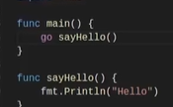 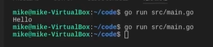
* 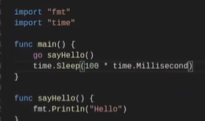 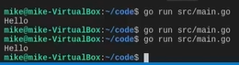
* 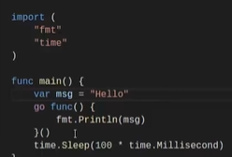 
* 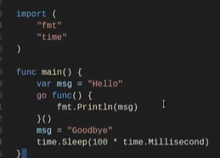 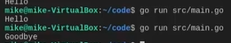
* 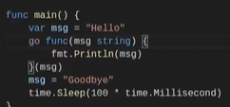 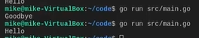
* waitgroup
* 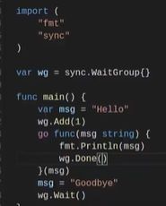
* Now once it’s done, we’re going to go ahead and exit the application. And we will do that by just waiting on the weight group. And we do that by using the weight method right here. Now when the go routine is done, then it can tell the weight group that it’s actually completed its execution. And we do that by using the done method.
* So if we execute that, basically, what that’s going to is it’s going to decrement, the number of groups that the weight group is waiting on. And since we added one, and it’s going to decrement by one to be down to zero, and then the weight method will say, Okay, it’s time for us to go ahead and finish up our application. So if I save this off, and I go ahead and run it, we see in fact that our application is performing as it did before.
* We can have multiple go routines that are working on the same data. And we might need to synchronize those together. And that can be a little bit tricky.
* 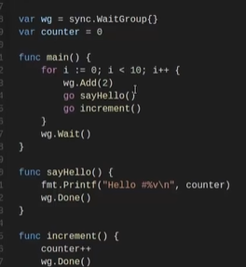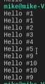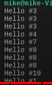
* We printed one twice, and then 24345, so that seemd to work consistently. And then we jumped all the way to nine, we printed 10 out twice, and then we went back to nine for some reason.
* And if we run this again, what happening here is our routines are actually racing against each other. So we have no synchronization between the goroutines, they’re just going hell bent for leather, and going as fast as they can to accomplish the work that we’ve asked them to do, regardless of what else is going on in the application.
* So in order to correct this, we need to find a way to synchronize these guys together. Now, we could probably find a way to use a weight group on this. But we’ve already talked about weight groups.
* Introduce this concept of a mutex.
* With the mutex.
* 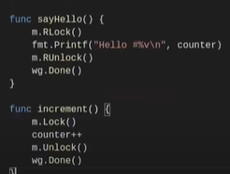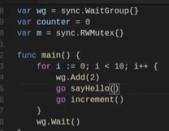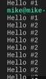
* A mutext is basically a lock that the application is going to honor. Mutex is locked, and something tries to manipulate that value, it has to wait until the mutex is unlocked. And they can obtain the mutex lock itself.
* We can actually protect parts of our code so that only one entity can be manipulating that code at a time. And typically what we’re going to use that for is to protect data to ensure that only one thing can access the data at a single time.
* With the reason that we have an issue here is we’re still working within the go routines. So if this say Hello, function gets executed twice by its go routines, and the increment function doesn’t get called in between. That’s where we get this behavior here, where we actually get the same message printing out twice, because we don’t have a chance to lock this mutex before we try and read it that second time.
* So the way to address this is we actually have to lock the mutex outside of the context of the go routine. So we have a reliable execution model.
* 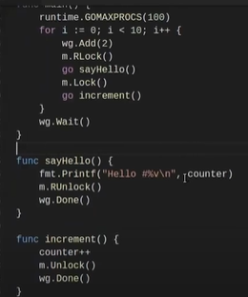 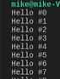
* now all I’ve done is I’ve moved the locks out here. SO the locks are now executing before each go routine executes. And then I unlock them when the goroutine is done.
* The reason that this is working is I’m actually locking the mutex is in a single context. So the main function is actually executing the locks. And then asynchronously, I’ll unlock them once I’m done with the asynchronous operation.
* Now the problem with this application is I basically have completely destroyed concurrency and parallelism in this application. Because all these mutexes are forcing the data to be synchronized and run in a single threaded way. So any potential benefits that I would get from the go routines are actually gone.
* Remove goroutine, and just running this with a single execution path and removing any concurrency at all.
* 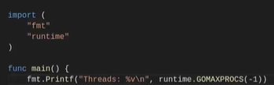
* 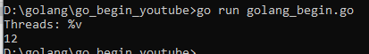
* So by default, go to do is it’s going to give you the number of operating system threads equal to the number of cores that are available on the machine. SO in this virtual machine, I’ve exposed 12 cores to the VM.
* SO I have by default 12 of threads that I can work with. Now, I can change that value to anything I want.
* 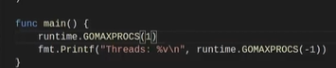 running single threaded
* SO now I have a truly concurrent application with no parallelism at all. SO this can be useful in situations where there’s a lot of data synchronization going on
* And you really need to be careful to avoid any kind of race conditions that parallelism can incur. And maybe there’s no better way to do it.
* So the general advice is one operating system thread per core is a minimum.
* But a lot of times you’ll actually find that your application will get faster by increasing go max procs beyond that value. Now if you get up too high like, example 100, then you can run into other problems, because now you’ve got additaionl memory overhead. Because you’re maintaining 100 operating system threads, your scheduler has to work harder because it’s got all these different threads to manage.
* I would encourage you definitely develop with go max procs greater than one because you want to reveal those race conditions as early as early as possible.
* But just before you release to production, you might to run your application through a performance test suite with varying values of go max procs, to see where it’s going to perform the best.

## Parallelism

## Bestpractices

* When work with concurrency remember check
  + Go run -race main.go
* 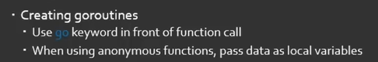
* 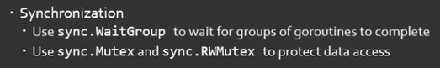
* 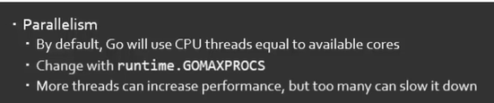
* 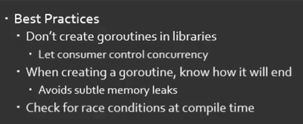

# Regex:

<https://www.golangprograms.com/regular-expressions.html>

<https://regexr.com/>

<https://github.com/google/re2/wiki/Syntax>

* Remove javascript, style in html

https://viblo.asia/p/golang-regular-expressions-L4x5xgBOlBM

* Get a string between parentheses ()
* 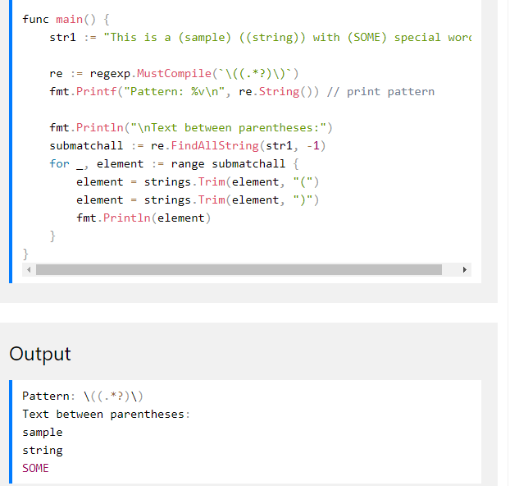
* go run . run all go in all folder
* go run *.go

# colly

* <https://blog.logrocket.com/web-scraping-with-go-and-colly/>
* <https://viblo.asia/p/thu-thap-du-lieu-voi-golang-colly-924lJ3y85PM>
* <https://github.com/gocolly/colly/blob/master/_examples/parallel/parallel.go>
* https://kanzitelli.medium.com/good-news-app-backend-in-golang-colly-usage-325ded0b5d34

# Chromedp: lazy load

* Delay crawl :

<https://pkg.go.dev/github.com/chromedp/chromedp#section-readme>

https://www.ribice.ba/golang-chrome-automation/

# get data from HTML string

<https://github.com/PuerkitoBio/goquery>

<https://golang.hotexamples.com/examples/github.com.puerkitobio.goquery/Document/Find/golang-document-find-method-examples.html>

# working with File:

<https://golang.hotexamples.com/examples/io.ioutil/-/WriteFile/golang-writefile-function-examples.html>

# time

* <https://blog.kennycoder.io/2020/12/18/Golang%E6%95%99%E5%AD%B8%E7%B3%BB%E5%88%97-%E4%BD%95%E8%AC%82WaitGroup-%E7%AD%89%E5%BE%85Goroutine%E7%9A%84%E5%A5%BD%E5%B9%AB%E6%89%8B/>
* Seconds

# HTTP Status Codes

* 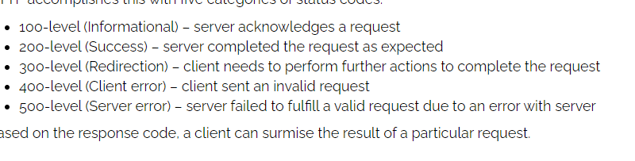

# Gcc:

* <https://preshing.com/20141108/how-to-install-the-latest-gcc-on-windows/>
* <https://stackoverflow.com/questions/47215330/how-do-i-install-gcc-on-cygwin/47222901>
* https://jmeubank.github.io/tdm-gcc/
* <https://www.youtube.com/results?search_query=how+to+install+gcc+in+cygwin>
* Open vscode and run

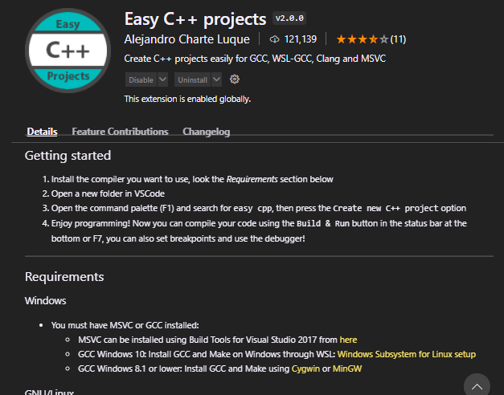

# Ubuntu learn:

<https://ubuntu.com/tutorials/command-line-for-beginners#5-moving-and-manipulating-files>

<https://github.com/acharluk/UsefulStuff/blob/master/windows/setup_wsl.md> setting ubuntu

* begin ubuntu:

<https://ubuntu.com/tutorials/command-line-for-beginners#1-overview>

* folder ubuntu on window:



* Install golang ubuntu

<https://linuxize.com/post/how-to-install-go-on-ubuntu-20-04/>

* Install docker

<https://docs.docker.com/engine/install/ubuntu/#install-using-the-convenience-script>

* Docker-compose ubuntu

<https://linuxhint.com/install-docker-compose-on-ubuntu/>

* Cannot connect to the Docker daemon at unix:/var/run/docker.sock. Is the docker daemon running?

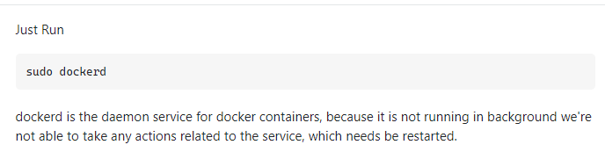

* Permission denied

<https://community.atlassian.com/t5/Confluence-questions/Folder-access-denied-ubuntu/qaq-p/1709825>

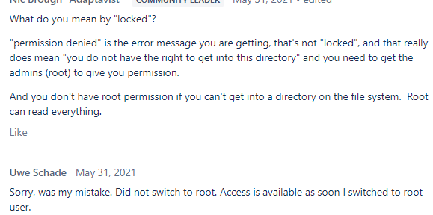

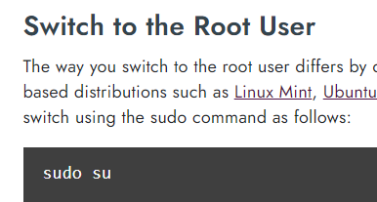

<https://www.lifewire.com/switch-user-su-command-3887179>

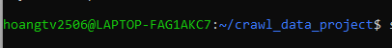



# Microservice architecture:

<https://microservices.io/patterns/data/saga.html>